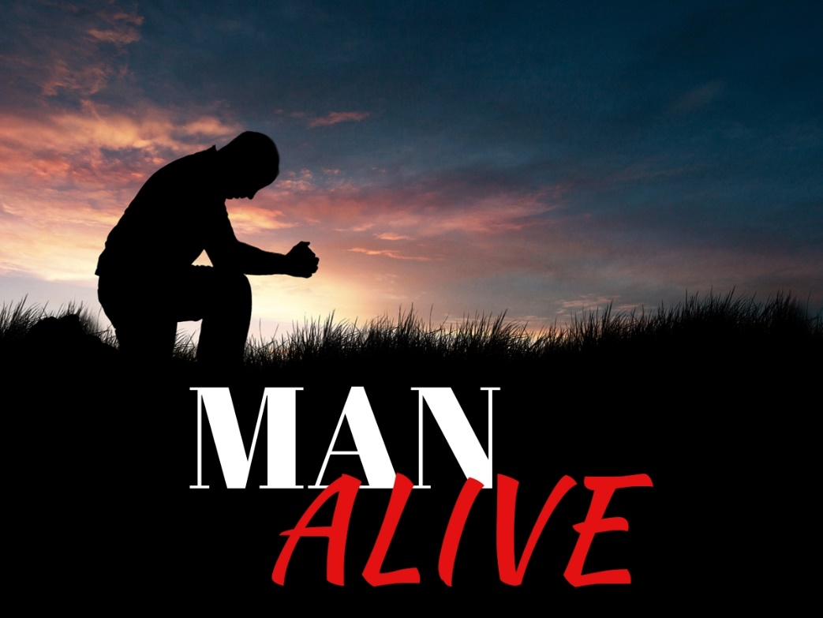
A MEN’S WEEKEND
OCTOBER 4TH - 6TH

SPEAKER: KEVIN DEVIRIES
COST: $125

SIGN-UP ONLINE
@ FRIENDSHIPWESELYAN.ORG
A MEN’S WEEKEND
OCTOBER 4TH - 6TH

SPEAKER: KEVIN DEVIRIES
COST: $125

SIGN-UP ONLINE
@ FRIENDSHIPWESELYAN.ORG
For men ages 16 and up.
Taking Place at Warner Camp:
60 - 55th St. Grand Junction, MI 49056

About the Speaker: Kevin DeVries speaks to tens of thousands of men, women, and students at national faith conferences, church services, school chapels, corporate and community. He is known for his engaging transparency, poetic metaphors, disarming humor and unbridled passion to create an experience and atmosphere where true change can happen.

Weekend Schedule:
​
Friday
4:30 Check-In/ Relax
- Arrow Tag
- Fishing Contest Begins
- Horseshoe/Tetherball/Basketball/Etc.
6:30 Dinner
7:30 Session #1: The Heroic Journey of God
9:30 Bonfire on the Hill
For men ages 16 and up.
Taking Place at Warner Camp:
60 - 55th St. Grand Junction, MI 49056

About the Speaker: Kevin DeVries speaks to tens of thousands of men, women, and students at national faith conferences, church services, school chapels, corporate and community. He is known for his engaging transparency, poetic metaphors, disarming humor and unbridled passion to create an experience and atmosphere where true change can happen.

Weekend Schedule:
​
Friday
4:30 Check-In/ Relax
- Arrow Tag
- Fishing Contest Begins
- Horseshoe/Tetherball/Basketball/Etc.
6:30 Dinner
7:30 Session #1: The Heroic Journey of God
9:30 Bonfire on the Hill
Weekend Schedule:
​
Saturday
8:30 Breakfast
9:30 Activities
- Climbing Walls/Zipline
- High Adventures Rope Course
- Biking/ Hiking

11:00 Session #2: True North
12:30 Lunch
1:30 Activities
- Arrow Tag
- Archery
- Biking/ Hiking
- Nap/ Rest
- Snack Store (4-5pm)
- Fishing Contest Ends (6:30pm, winner declared
at Session #3)

6:00 Dinner
7:30 Session #3: Climb Your Mountain
9:00 Late Night: Finding Noah
Sunday
8:30 Breakfast
9:30 Session #4: Cave of Kings
10:30 Check-Out by Noon
Weekend Schedule:
​
Saturday
8:30 Breakfast
9:30 Activities
- Climbing Walls/Zipline
- High Adventures Rope Course
- Biking/ Hiking

11:00 Session #2: True North
12:30 Lunch
1:30 Activities
- Arrow Tag
- Archery
- Biking/ Hiking
- Nap/ Rest
- Snack Store (4-5pm)
- Fishing Contest Ends (6:30pm, winner declared
at Session #3)

6:00 Dinner
7:30 Session #3: Climb Your Mountain
9:00 Late Night: Finding Noah
Sunday
8:30 Breakfast
9:30 Session #4: Cave of Kings
10:30 Check-Out by Noon

